# Lab2

## 1.Understanding the architecture

**a) Lighthouse:** A virtual machine with a public IP address (for example, on Google Cloud, Ionos). It serves as the coordination center of the network, helping other nodes discover each other and establish direct peer-to-peer connections. The fixed IP of Lighthouse in the Nebula network is 192.168.100.1.

**b) Node:** Personal computer (here, we use windows). They are located behind different NATs and do not have a fixed public IP. They need to connect to Lighthouse to join this virtual network.

# 2.Download Nebula for Windows

Visit the GitHub release page of Nebula **https://github.com/slackhq/nebula** and find the latest version and download the compressed file suitable for Windows, such as **nebula-windows-amd64.zip**.

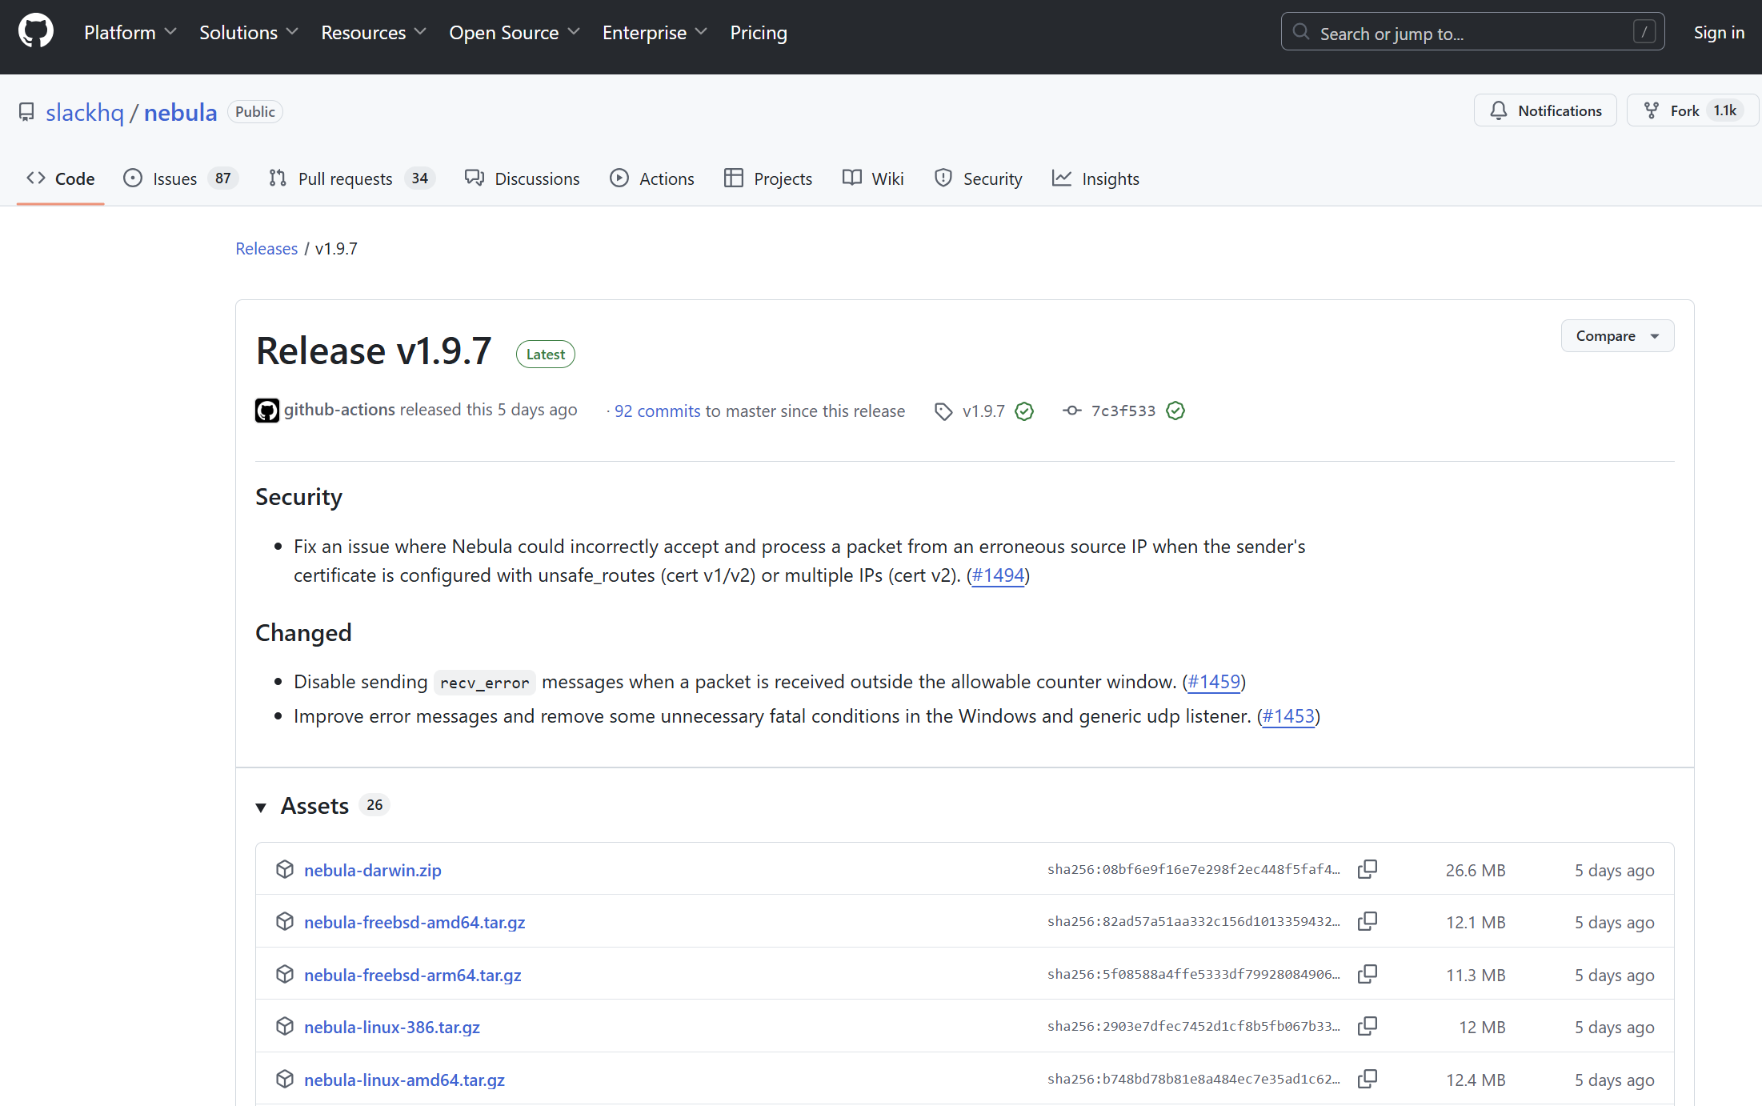

Extract the compressed file to D:\nebula. After extraction, we will obtain files such as nebula.exe and nebula-cert.exe.

## 3. Prepare the certificates and configuration files

## 3.1 Data comparison of lighthouse and local machine yaml files

Use the data comparison tool (**Meld**) to compare the attached configuration files **Lab.2.lighthouse.config.yaml** and **Lab.2.MBP15.config.yaml**. We can find the differences through **Table 1** below.

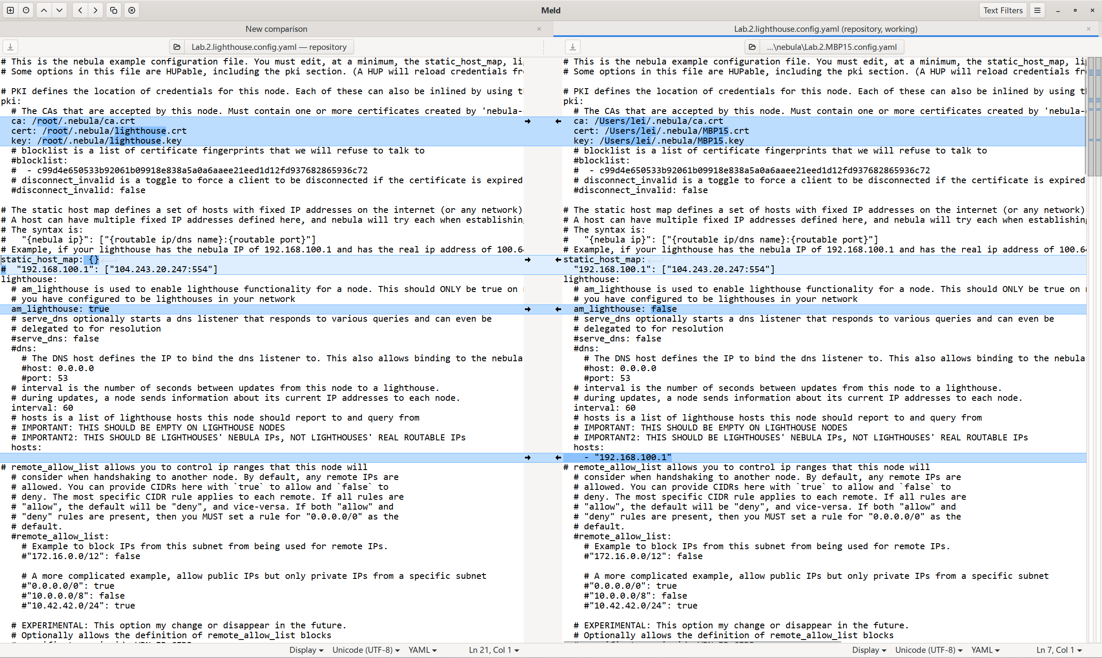

**Table 1 Differences between two config files**

|  |  |  |
| --- | --- | --- |
| Configuration item | Lighthouse | MBP15 (Mac) |
| pki cert path | Linux path | Mac path |
| am_lighthouse | true | false |
| static_host_map | null | config |
| lighthouse.hosts | null | 192.168.100.1 |

## 3.2 Modify the local yaml file

Copy the three certificate files (**zhaoyijie.crt, zhaoyijie.key, ca.crt**) obtained from the lecturer to the Nebula directory.

Similarly, also copy the configuration file provided by the instructor (local machine **config.yaml**) to this directory.

Modify the pki field with our local certificate path in the config.yaml file of our local machine.

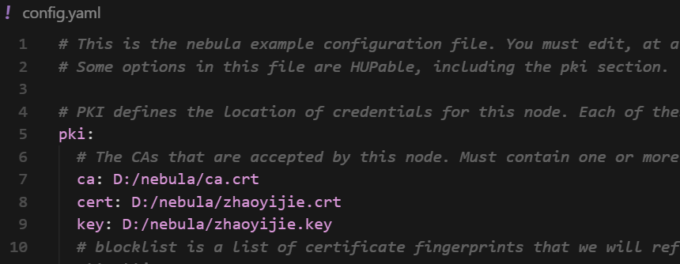

# 4. Install and run Nebula

On Windows, we need to run Nebula with administrator privileges because it requires the creation of a virtual network adapter.

In the open Command Prompt window, use the cd command to switch to your Nebula directory and run the following command to test the syntax of the configuration file:

**nebula.exe -test -config config.yaml**

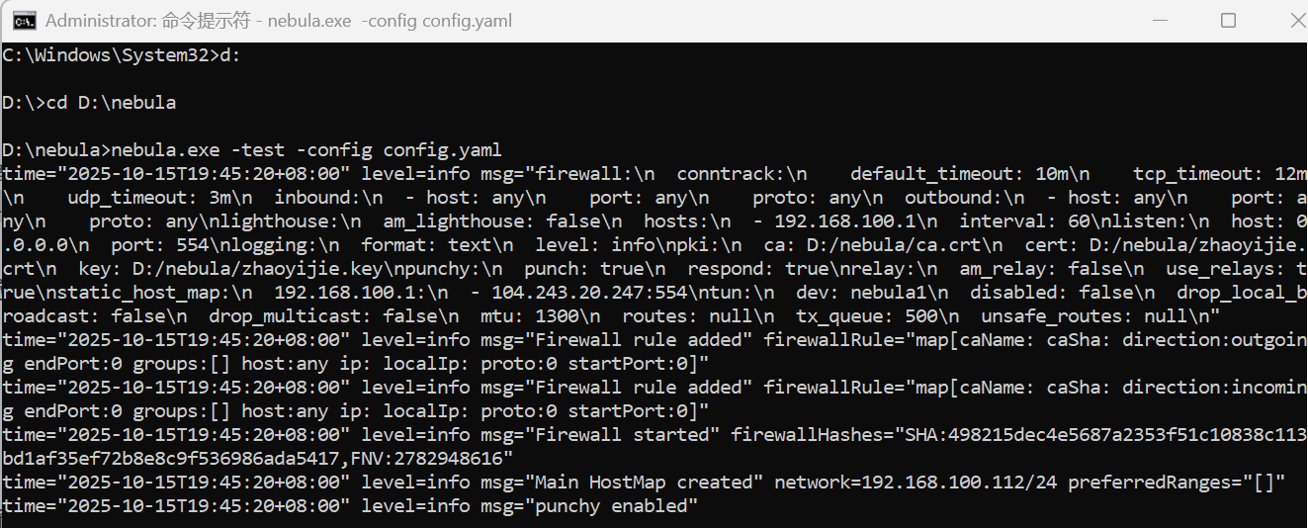

Run the following command to start Nebula (with administrator privileges):

**nebula.exe -config config.yaml**

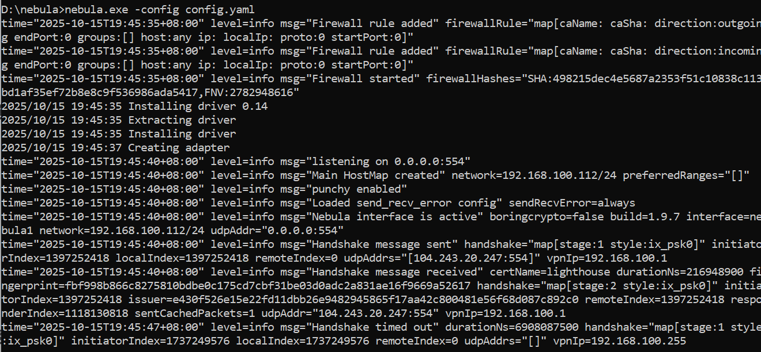

We can observe that:

1. Installation of driver was successful

**Installing driver 0.14 Creating adapter**

2. The Nebula interface has been activated. Our node has obtained the IP address: 192.168.100.112.

**Nebula interface is the active interface = nebula1 network = 192.168.100.112/24**

3. Successful initial handshake with Lighthouse. We successfully established an initial connection with Lighthouse (192.168.100.1).

**Handshake message received with lighthouse**

# 5. Verify whether the connection has been successful

## 5.1 Test the connection with Lighthouse

Successfully received a response from Lighthouse (192.168.100.1). The delay is within a reasonable range (191 - 200 ms).

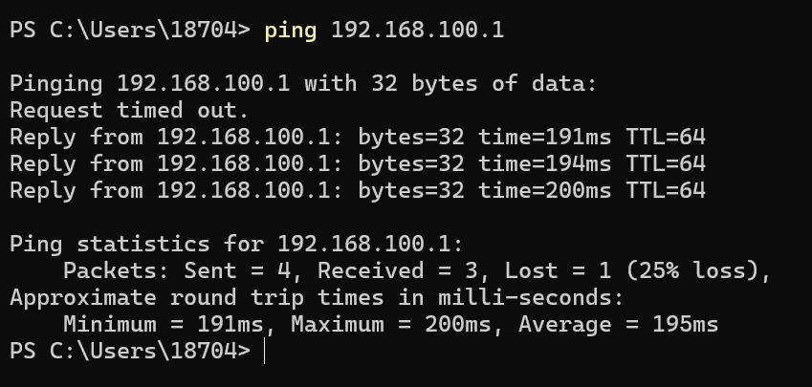

## 5.2 Check the network interface

Nebula1 virtual adapter has been created successfully. Obtained the correct IP address: 192.168.100.112.

